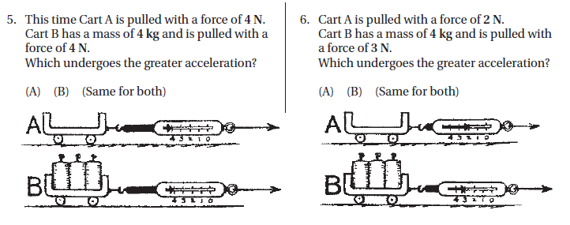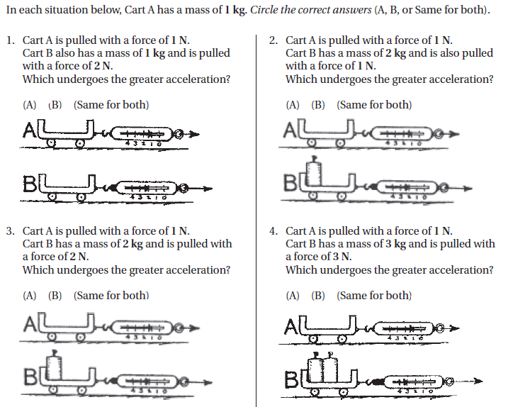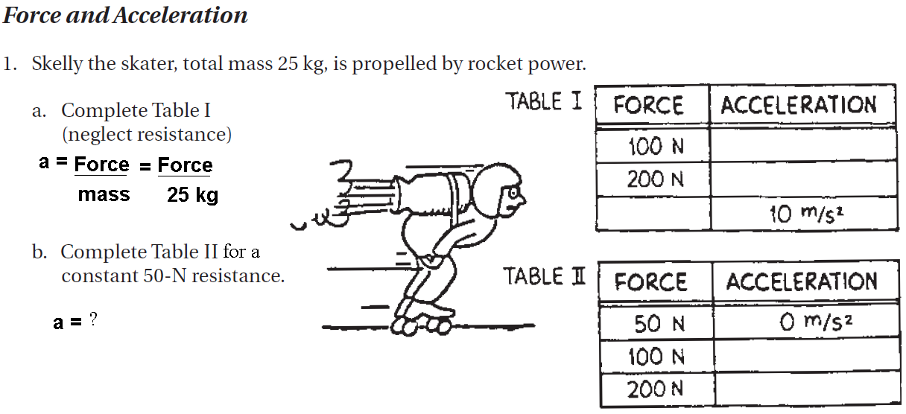

**Newton’s Second Law- Concept Development Practice Worksheet :**

***Force, Mass and Acceleration***

***Mass and Acceleration***